The three functions I decided to choose to experiment with are CREATE TABLE, LIMIT, and ALTER. I picked these three because I felt that these are ones I would most likely come into contact with actually using SQL.

1) First one I want to cover is going to be the ALTER function. This one I think as a new student and someone experimenting and learning SQL will probably use it quite often. For example, while trying to do the example for one of the other parts of this assignment I found myself needing to alter a table’s data type.

ALTER TABLE *table_name* MODIFY COLUMN *column_name data_type;*



So if the query is run and we find within the column or table the condition necessary it will return true where we can then run other related queries.

2) For CREATE TABLE this one is when we are using a database and want to create a table to store data and information in.

W3Schools has the syntax as follows

CREATE TABLE *table_name* (

*column1 datatype*,

*column2 datatype*,

*column3 datatype*,

....

);

Although we can setup a primary key, by using PRIMARY KEY() after one of the columns and then type within the parenthesis which column to be the primary key.

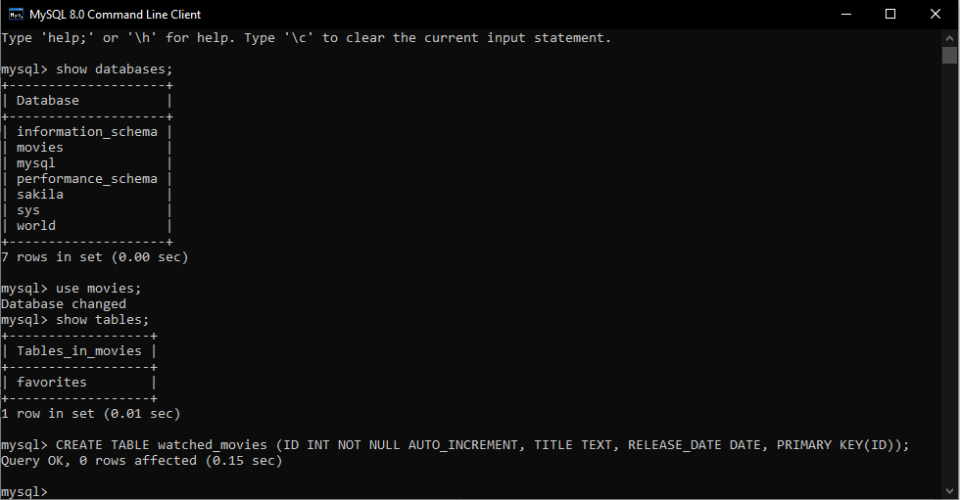

3) The last one I want to cover is going to be the LIMIT function. This one I found interesting because you can order the rows before limiting which ones you get so if you want the top 3 rows you can do it by the ID primary key that auto increments or you can sort them by release date.

SELECT * FROM *table_name* ORDER BY *column_name* LIMIT <*int>;*

